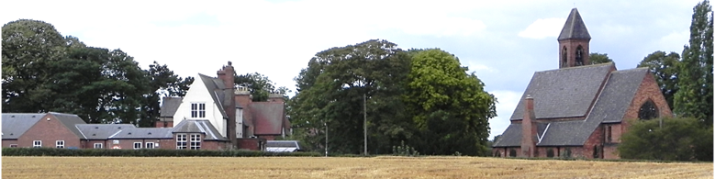Hensall Parish Council

Official Notice of Annual Parish Meeting to be held in the

Methodist Hall, Hensall

on Tuesday 18th May 2021 at 7:15 pm

Any parishioner is entitled to attend this meeting and raise any concerns or questions they may have about the Parish with the Parish Council.

All present to sign the Attendance Book

**AGENDA**

APM 2101 Election of person to Chair the Annual Parish Meeting.

APM 2102 Chair to welcome all present.

APM 2103 Apologies.

APM 2104 No Annual Parish Meeting was held in 2020 because of the Covid outbreak.

Minutes of the Annual Parish Meeting of the 14th May 2019.

Chair to sign if accepted.

APM 2105 To receive a report of Parish Council activities since May 2019.

APM 2106 To receive electors comments about the report.

APM 2107 Electors comments.

Signed.  Chair 10th May 2021