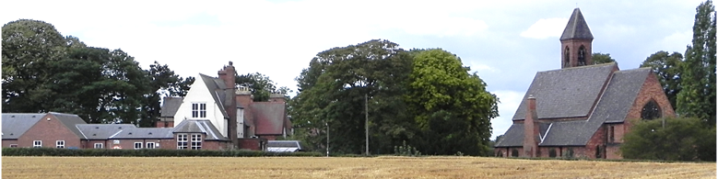
Hensall Parish Council

MINUTES OF HENSALL ANNUAL PARISH COUNCIL MEETING

on the 10th May 2022 at 7:30 pm in the School Hall

Present: Cllrs. R Tams, N Reeson, A Brennan, A McKenna and C Ainsworth.

Clerk – Mr. D Tredgett and 5 members of the public.

052201 Election of Chair Cllr. Tams was elected as Chair.

052202 Welcome The Chair welcomed everyone present at the meeting and in particular the

new Cllrs A Brennan and A Mckenna.

052203 Apologies Cllrs , G Mason and T Elliott-Adams.

052204 Public Session The length of time some street lights were out of action was again criticised.

The speed of traffic entering the village from the A 645 from Snaith was seen as a major concern. The need for both residents and the Parish Council to raise this issue with NYCC was agreed.

The A 645 carriageway damage outside the Keedwell Garage was raised.

052205 Minutes of previous meeting Resolved The minutes of the Meeting of the
29th March 2022 were approved and signed by the Chair.

052206 Cllr. Reports Cllr Tams had attended virtual YLCA meetings.

Parking on Bird Lane continues to be a problem.

052207 Clerk’s Report Yorkshire Water have not yet analysed the sewer survey on Station Road.

NYCC have been contacted regarding the maintenance of the Street Lights.

NYCC have been asked to clear the Station Road footway.
The Conservation Volunteers have provided an estimate for the construction of a footpath for disabled use to the Station Road Play area.

052208 Planning Applications Hazel Grove Farm No comments
Alsuno, Hazel old Lane No comments

Decisions None

052209 Parish Field The Solicitors have instructed the County Baliffs to complete the repossession.

052210 Flood Banking Both of the farmers involved are now happy to proceed and a meeting with the Environment Agency can now take place.

052211 Station Road Play Area The bases have been constructed and levelling the ground has now begun.

052212 Xmas Lighting Meetings to commence after the Queen’s Jubilee

052213 Traffic Surveys These are to take place on the 6th – 14th June.

052214 Community Speed Watch A session has taken place on the A 645.

052215 Queen’s Jubilee All the preparations have now been completed for the 5th June.

052216 Internal Auditor The Internal Auditors report was discussed along with the
AGAR certificate of exemption to the External Audit

Resolved To accept the Internal Auditor’s report and submit the Certificate of Exemption.

052217 Responsible Financial Officer’s Report

- Current balance £ 29,416.61

- Payments received Precept £ 8000
VAT refund £ 1618.40
£ VAT Total
- Payment made Danum Drainage 16.36 16.35 BT

c) Payments to be made NYCC lights Energy 2947.34 589.47 3536.81 BHIB Insurance 1107.35 1107.35

Hensall Church 300.00 300.00 Internal Audit 80.00 16.00 96.00 Grass cutting 505.00 505.00

Resolved To accept the report .

052218 Graveyard Maintenance Resolved The payment of £300 was formally agreed.

052219 Bird Lane Play area A site visit is required to consider how to refurbish the area.

052220 Questions None

052221 Minor Items Concern regarding a traffic sign at the Wand Lane/A 19 junction.

Broken service box at the Bird Lane/Main Street junction.

052222 Items for Next Agenda Grass cutting .

052223 Next Meeting. 5th July 2022 in the School Hall.

052223 Closure of meeting 9:00 pm

Signed ____________________________________ Chair Date _________________2022

