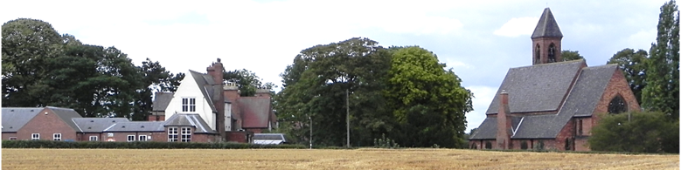
Hensall Parish Council

MINUTES OF HENSALL PARISH COUNCIL MEETING

on the 29th March 2022 at 7:15 pm in the School Hall

Present: Cllrs. R Tams, N Reeson, T Elliott-Adams and C Ainsworth.

Clerk – Mr. D Tredgett, District Cllr. M Jordan and 10 members of the public.

032201 Welcome The Chair welcomed everyone present at the meeting.

032202 Apologies Cllrs , H Hatfield, P Williams, G Mason and District Cllr Richardson

032203 Public Session The length of time some street lights were out of action was criticised.

The Clerk was asked to complain to the bus and rail providers regarding the lack and quality of the timetable information.

A request for a footway/cycle path to Eggborough was made again.
Clerk to contact NYCC.

A request was made for some support from the Parish Council for the provision of a play area at the rear of the Methodist Chapel.
A meeting is to be held to discuss the actual requirements.

The applicant for a farm shop on the field opposite the school raised concern at the possible refusal for planning permission. Clerk to seek information.

The footpath on Station Road requires the soil clearing at the back of the footpath.
Clerk to contact NYCC

032204 Minutes of previous meeting Resolved The minutes of the Meetings of the 15th February 2022 were approved and signed by the Chair.

032205 Cllr. Reports Cllr Tams had attended virtual YLCA meetings.

A letter requesting motorist to park more sensibly on Bird Lane has been given to 3 local residents and the Restaurant owner.

032206 Clerk’s Report Yorkshire Water have not yet analysed the sewer survey on Station Road.

The Low Cost Housing survey has shown an affordable housing development for
6 – 9 properties would be appropriate with a mix of houses and bungalows.

NYCC does not have the financial resources available to repair Heck Lane.

St Paul’s Church requested a donation towards the maintenance of the Church Yard. A donation of £ 300 will be formally agreed at the next meeting.

032207 Planning Applications None

Decisions None

032208 Parish Field The Solicitor has recommended further delaying the clearance date following some communication between Mr Ward and his solicitor.

It was agreed not to delay the matter any further and proceed with the clearance.

032209 Flood Banking The use by walkers is still awaiting further discussions with the EA and both of the farmers involved.

032210 Station Road Play Area The bases have been constructed and levelling the ground has now begun.

032211 Xmas Lighting No progress to date.

032212 Traffic Surveys These are to take place on the 6th – 14th June.

032213 Community Speed Watch Training has been completed and the equipment is available.

032214 Queen’s Jubilee Resolved To donate £ 600 to the Village Events Team
towards the cost of the celebration.

032215 Internal Auditor Resolved To appoint Rachel Pearson as the Internal Auditor

032216 Parish Elections All application forms have to be submitted by the 5th April.
The Clerk is available to assist residents if required.

032217 Responsible Financial Officer’s Report

- Current balance Bank Account £ 20,859.15
Cash in hand £18.00

- Payments made Methodist Hall 15.00 15.00 BT
HMRC 87.60 87.60 BT
Payroll 35.50 7.10 42.60 BT

c) Payments to be made Clerking 349.98 349.98

Clerk’s Exp 56.26 56.26

Next Financial Year

Clerking 349.98 349.98

HMRC 87.60 87.60

NYCC 260.00 52.00 312.00

YLCA 313.00 313.00

- End of Year Accounts were presented Receipts and Payments

End of year Spend

Expenditure/ Budget
Resolved To accept the report .

032218 Questions None

032219 Minor Items The Bird Lane play area requires some cosmetic treatment.

032220 Items for Next Agenda Bird Lane play area upgrading.

032221 Next Meeting. 10th May 2022 in the School Hall.

032222 Closure of meeting 9:00 pm

Signed ____________________________________ Chair Date _________________2022

