Hensall Parish Council

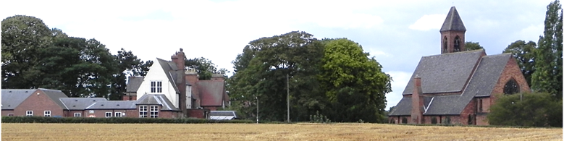

Clerk and Responsible Financial Officer

Mr D Tredgett, The Spaniels, Field Lane, Hensall

E-mail:- [parishclerkdt@talktalk.net](mailto:parishclerkdt@talktalk.net) : Tel 01977 661858

Rebecca Gray

The Planning Inspectorate

Room C

Temple Quay House

The Square 12th June 2025

Bristol

Dear Madam

Station Road Farm, Hensall

The Parish Council re affirms its objection to the application for the use of building and land for storage. Whilst the Parish Council did not object to the initial use of the field for agricultural purpose the use of the site for the storage of vehicles raised concern in the village and was seen as having a negative impact, hence the objection from the Parish Council and numerous resident to the retrospective application.

The increase in activity which now includes the use of nearly all of the field has only increased the objections to its use in this way.

The Parish Council totally supports the refusal of Planning Permission by North Yorkshire

Council.

Residents have also reported an increase in noise and activity from the site and the Police have been active in removing vehicles from the site.

Dennis Tredgett

Parish Clerk